GEORGIA PERFORMANCE MANAGEMENT PROCESS OVERVIEW

Performance Management is an ongoing process of employees by managers to manage and ensure employee success. Performance management involves managers and employees in achieving shared state, agency, unit and personal goals through planning, coaching, and evaluation.
Employees are engaged in the establishment and documentation of establishing clear expectations and providing ongoing feedback and coaching to ensure those expectations are achieved. Performance management is a partnership between the employee and his/her manager and should be focused on the ongoing communication between the employee and his/her manager.
How does Performance Management add value to your organization?
- Encourages success through clear, documented expectations
- Offers opportunities for manager/employee engagement around state, organizational, and unit goals and plans so everyone learns their role in personal and organizational success
- Presents measurable and observable criteria for assessment and allows fair and objective bases for evaluations
- Provides at least two formal opportunities for feedback to employees at all levels to review exemplary performance and needed improvement so that employees can choose success.
- Provides formal opportunity for individual development planning to grow each employee’s skill sets and prepare for potential advancement.

What does Performance Management do for you, your manager, and your organization?
- Drives accountability throughout the organization
- Ensures there is alignment between individuals’ goals and objectives and their agency’s goals and strategic plans
- Drives clear expectations with measurable, objective criteria
- Provides opportunities for feedback to employees
- Supports individual development planning to expand individuals’ skill sets

Why does Performance Management work to add value?
- Clear, documented expectations increase morale because every employee knows what is expected and has the opportunity to succeed based on stated expectations
- Managers and their employees are more fully engaged as each member of the organization sees how they fit in the big picture, and how they are helping the organization to serve the citizens of Georgia.
- Organizational trust and loyalty increase as employees see direct relationships between set goals and expectations and achievements of those goals and expectations
- Expectations for employee success are managed by formal opportunities to discuss progress toward goals.
- Employees are recognized as professionals through opportunities to achieve their own professional growth goals.

Guiding Principles of Performance Management
- People drive improved performance, not forms. Focus is relationships and feedback
- Performance management is a partnership between the manager and the employee
- There should be no surprises at review time
- Specific and objective feedback is key
- All individual performance goals should be linked to those of the department or agency
- Performance should be evaluated on what is to be accomplished as well as how it is to be accomplished
- Performance should be carefully measured and documented to ensure fairness and objectivity

The State of Georgia’s Performance Management Process consists of four phases:
- Performance Planning  - Performance Coaching  - Performance Evaluation  - Performance Recognition | 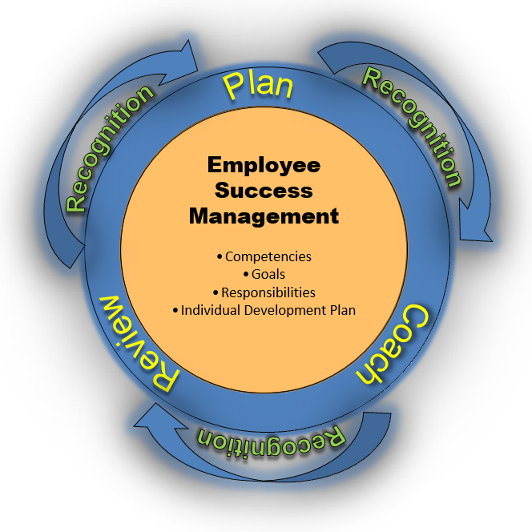
Performance Planning

Performance management begins with the planning phase. During the planning phase, the manager and the employee work together to develop a performance plan for the new performance cycle. The performance plan includes core/individual competencies, goals and/or job responsibilities. These performance expectations determine WHAT is to be accomplished, HOW it is to be accomplished, HOW and WHEN progress is to be measured and the TIMEFRAME in which the expectation is to be accomplished. All performance expectations should be set at the Successful Performer level. Also, an Individual Development Plan (IDP) for the employee is included to help the employee be more successful in their current job or to prepare them for future roles.

The purpose of performance planning is for the manager and the employee to collaborate and develop performance expectations for the employee for the upcoming year. This means:
- Identifying the necessary competencies (demonstrated attributes and behaviors) to achieve results
- Setting individual goals that are aligned with the State and the Agency’s mission, vision, and goals
- Identifying key job responsibilities – exactly “what” will be accomplished in the upcoming year
- Collaboration between manager and employee to develop an individualized development plan (IDP) to help develop the employee in the current position or to broaden skills sets to develop for future positions or roles in the Agency or state
GEORGIA PERFORMANCE MANAGEMENT PROCESS OVERVIEW
All employees should receive a performance plan from their manager at the beginning of the performance plan cycle or within 45 days of hire, transfer, promotion or demotion. Performance management is not just a once-a-year evaluation and planning session.

Competencies

The table below lists the competencies to be used in the performance management process. A competency is the knowledge, skill or ability that contributes to a successful job performance.

There are 18 competencies in all: 5 statewide core competencies which are required for all state employees, 2 leadership competencies which are required for all people managers and other leaders and 11 additional behavioral competencies which can be used as applicable for any state employee.

Statewide Competencies
(Automatically populated in Section 1: Core/Individual Competencies)
Core Competencies  (apply to all employees) | Leadership Competencies  (applies to those who manage others)
- Customer Service  - Teamwork and Cooperation  - Results Orientation  - Accountability  - Judgment and Decision Making | - Talent Management  - Transformers of Government
Additional Behavioral Competencies
(May be added in Section 1 as appropriate)
- Communication  - Conflict Management  - Creativity and Innovation  - Cultural Awareness  - Flexibility  - Initiative | - Negotiation and Influence  - Professional Development  - Project Management  - Teaching Others  - Team Leadership

Performance Coaching

Performance coaching involves consistent, two-way communication between the manager and the employee. Performance management is an ongoing process. Throughout the performance period, the manager must observe and document employee performance results and behaviors. In addition, the manager needs to provide feedback to the employee, both good and corrective, on an ongoing basis. The manager needs to coach the employee and also remember to provide developmental opportunities for the employee. The manager and employee are both encouraged to keep performance notes of activities and accomplishments during the performance period.

Coaching is used for four general purposes:
- To begin an effective behavior
- To help employees correct deficiencies
- To encourage continued good performance
- To stretch performance to the next level

Performance Evaluation
PHASE 3: PERFORMANCE EVALUATION
The manager will receive a notice from their agency’s HR Department when it is time to begin the mid-year or annual review process. The manager evaluates the employee at the end of the performance period. The performance notes that the manager kept during the year is a useful source of information. It helps the manager remember what happened six months ago in addition to what has happened more recently. The manager will determine individual ratings for each of the performance expectations that are in the plan: core competencies, goals, and/or job responsibilities. The manager should also review the employee’s self-evaluation (described below), as this is another source of information. The employee’s input is an effective platform for comparing what the manager has observed and documented was accomplished with the employee’s insight.

- Annual (End-of-Year) Performance Evaluation – This is the formal performance evaluation that determines an employee’s performance ratings for the year. These go on the employee’s permanent record
- Interim (Mid-year, Quarterly) Performance Evaluation – These are formal discussions where ratings are given on all the performance expectations in the performance plan. This is status check and will not be a final rating or go into the employee’s formal personnel file.

Rating | Description
Exceptional  Performer (5) | Employee exceeded all performance expectations. Employee was an exceptional contributor to the success of his/her department and the State of Georgia. He/she demonstrated role model behaviors.
Successful  Performer – Plus (4) | Employee met all and exceeded most (more than 50%) of the established performance expectations.
Successful  Performer (3) | Employee met all performance expectations and may have exceeded some (less than 50%). Employee was a solid contributor to the success of his/her department and the State of Georgia.
Successful  Performer – Minus (2) | Employee met most (more than 50%), but failed to meet some (less than 50%) performance expectations. Employee needs to further improve in one or more areas of expected job results or behavioral competencies.
Unsatisfactory  Performer (1) | Employee did not meet all or most (more than 50%) of the established performance expectations. Employee needs significant improvement in critical areas of expected job results or behavioral competencies.
Not Rated (N) | New hire or transfer within five months of end of performance period.

Performance Evaluation Process Steps

- The employee completes a self-evaluation.

Employees are strongly encouraged to rate their own performance using a self-evaluation. The employee will use the same 5-point rating scale as the manager to evaluate his or her performance.

The employee should refer to his or her performance notes to help with the evaluation process. The employee will give their completed self-evaluation to their manager and keep a copy for him- or herself. The supervisor and employee may want to meet to discuss accomplishments prior to completing the performance evaluation.

- The manager completes the performance evaluation.

Sections 1-3, Manager enters comments and ratings for each competency, goal or job responsibility that was established during the Performance Planning phase.

Individual Development Plan (IDP), the manager indicates progress the employee has made on activities in the IDP. The IDP is not rated.

- The manager submits the performance evaluation to his/her manager for approval.

- The manager’s manager either approves the document or requires changes and returns it to the manager to make changes.

- Once the manager’s manager approves the evaluation; it is submitted to HR for approval. HR will either approve the performance evaluation or indicate required changes. Changes are made and returned to HR for approval.

- The manager conducts the formal performance evaluation meeting. Note: The manager MUST have HR’s approval before conducting the evaluation meeting.

- Both the manager and the employee “finalize” the document in ePerformance to close out the evaluation.

The employee’s acknowledgement is not intended to signify that he or she approves of the review, but to signify that a performance review was held.

Note: These steps may be modified based upon the Agency’s internal performance management policy.

